Project Development Phase
Model Performance Test
Date | 16 September 2026
Team ID
Project Name | Medical Diagnostic Center – ServiceNow
Maximum Marks | As per evaluation criteria
Model Performance Testing
Since the Medical Diagnostic Center is a ServiceNow application and does not use a machine-learning model, training accuracy, validation accuracy and fine-tuning accuracy are not applicable. Instead, the application was tested based on its functional workflow, automation, data handling and Service Portal performance.
S.No. | Parameter | Values | Screenshot
1 | Application Summary | ServiceNow-based Medical Diagnostic Center application with Test Catalog, Appointment Booking, Payment, My Appointments and My Lab Reports modules. | 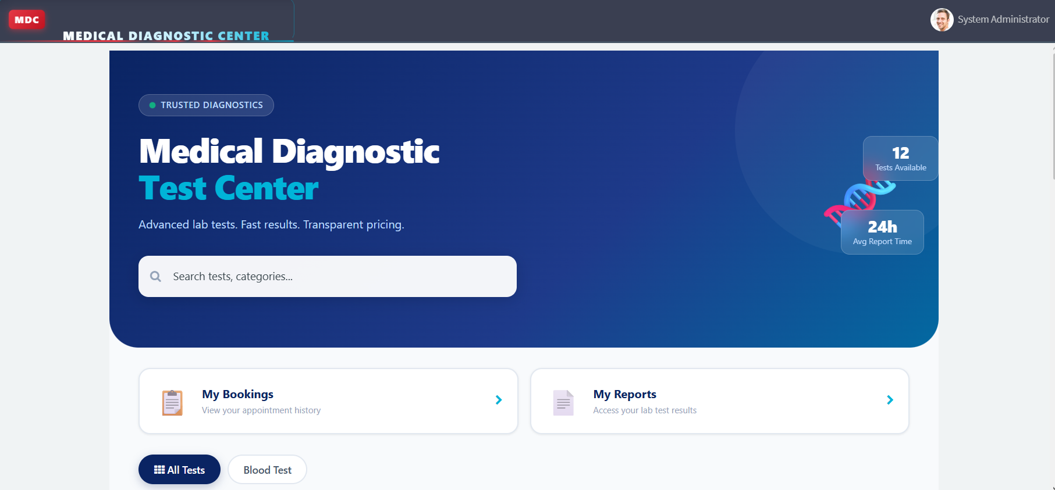
2 | Functional Testing | Test browsing, test selection, patient details, appointment booking, payment status, appointment tracking and report viewing were tested. | 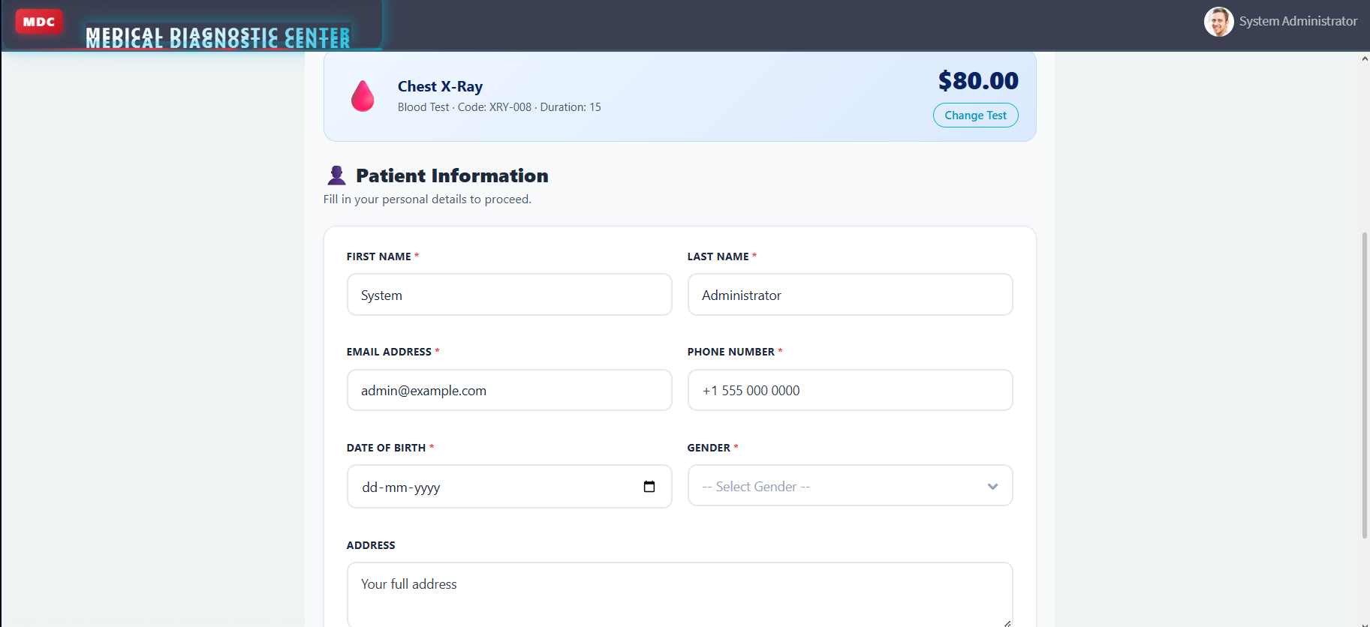
3 | Appointment Testing | Appointment creation, date/time selection, status updates and eligible appointment cancellation were tested successfully. | 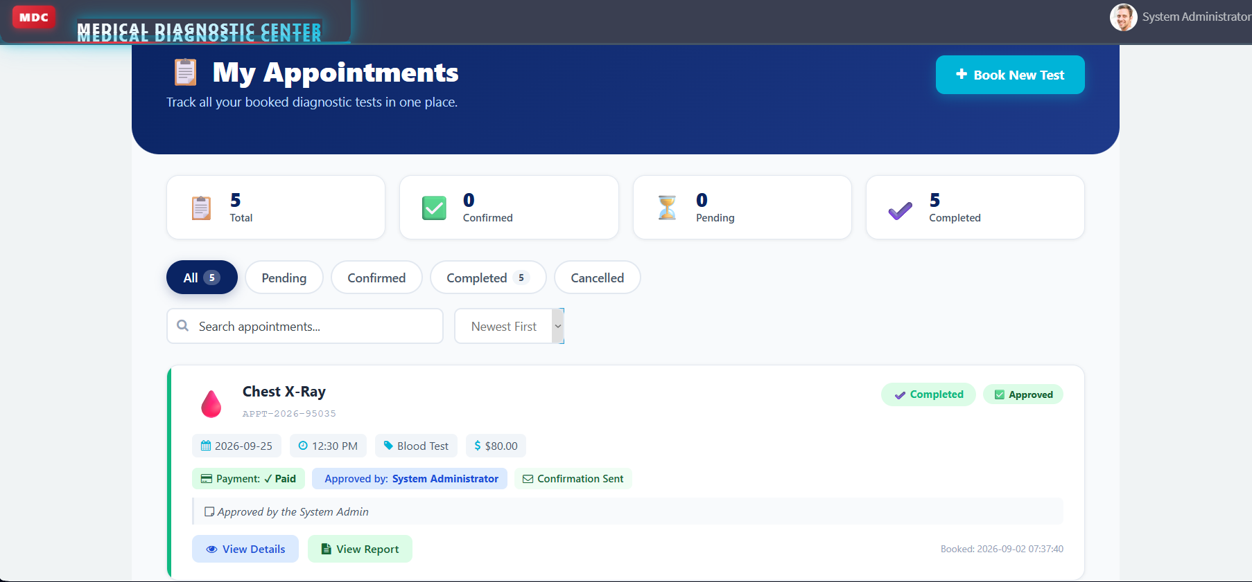
4 | Payment Testing | Payment information and payment status were tested as part of the appointment workflow. | 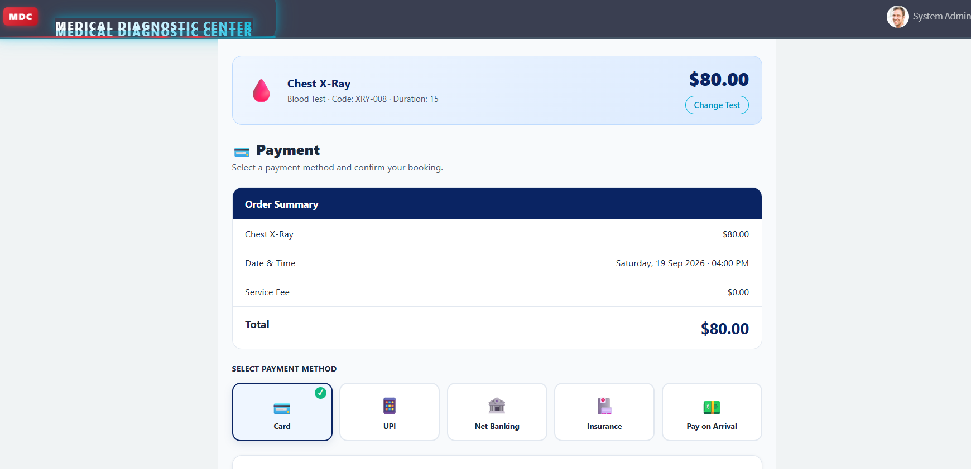
5 | Report Testing | Laboratory report generation, report status, findings, report details and patient report access were tested. | 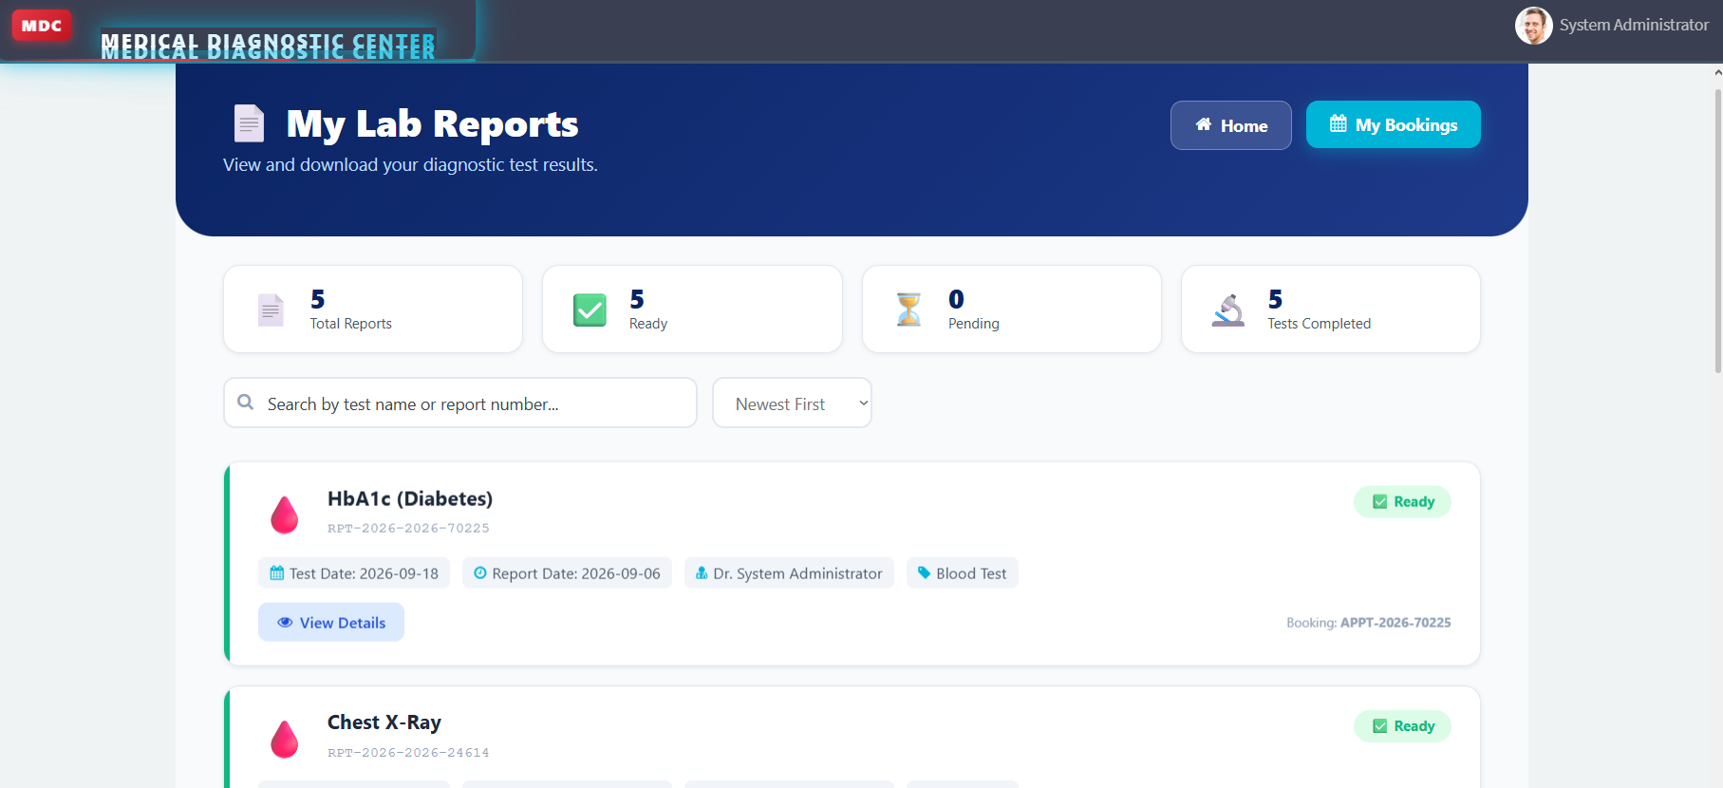
6 | Automation Testing | Business Rules were tested for automated processing, including laboratory report generation when an appointment is completed. | 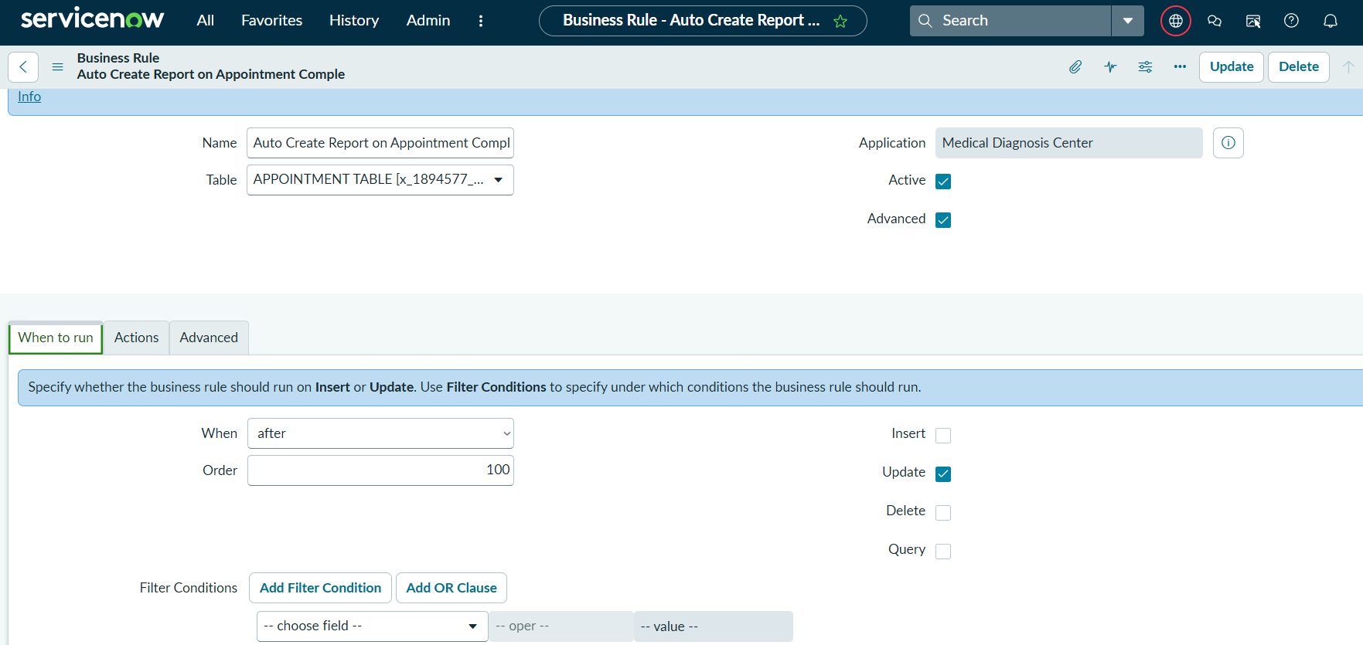
7 | Notification Testing | Appointment and report-related notification functionality was tested. | 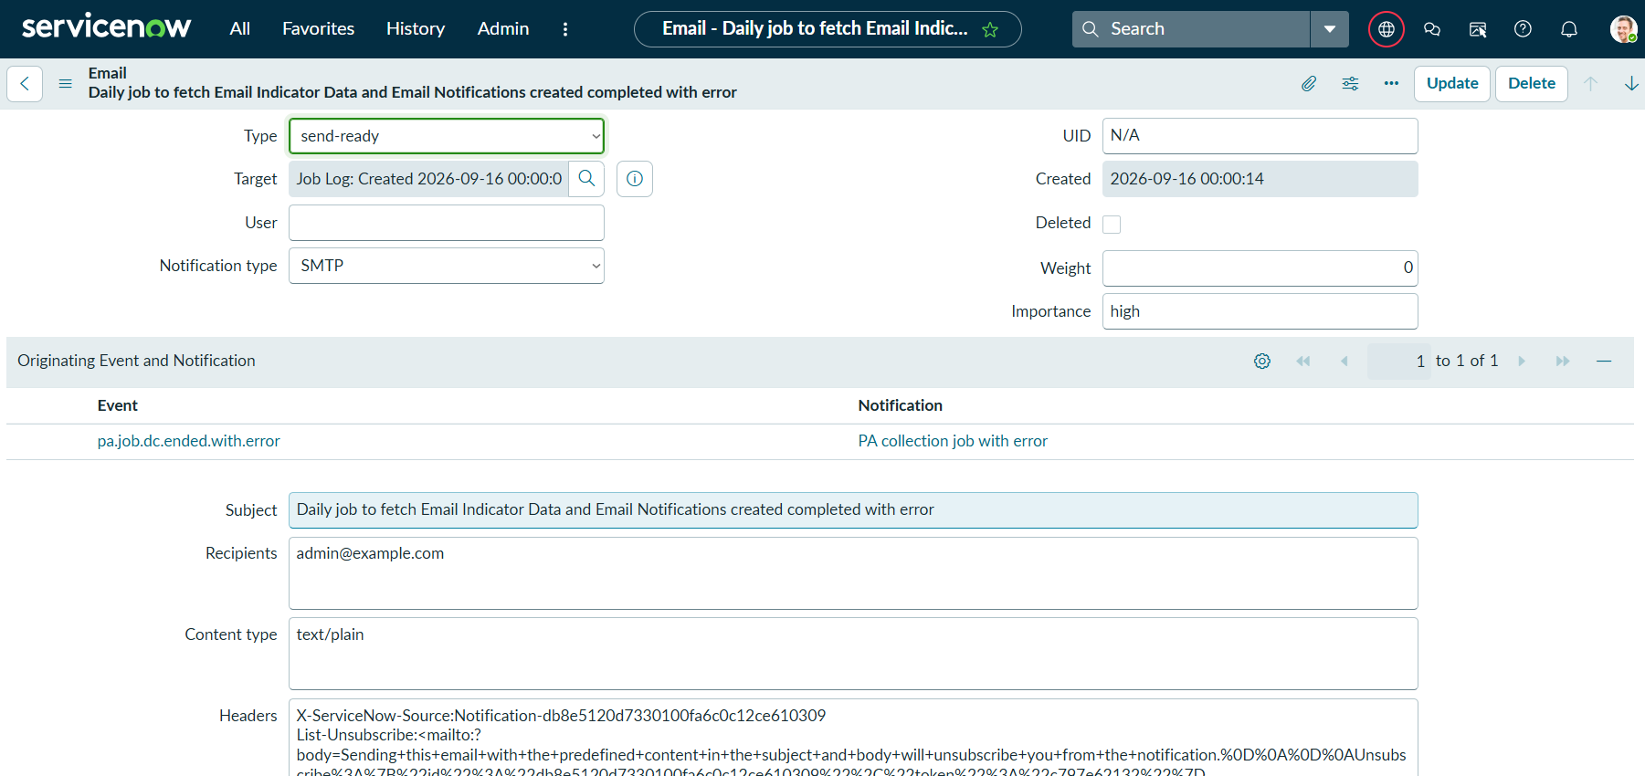
8 | Security Testing | Role-based access and ServiceNow access controls were considered to restrict access to application data. | 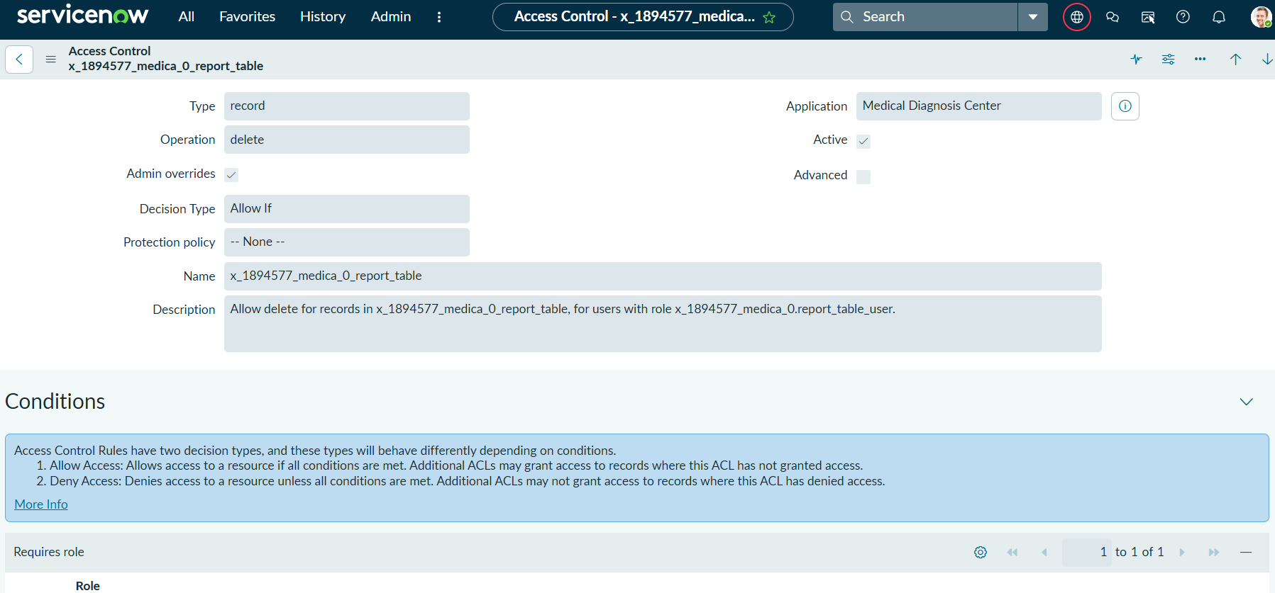
9 | User Interface Testing | Service Portal pages, navigation, search, filtering, sorting, buttons and report-detail views were tested. | 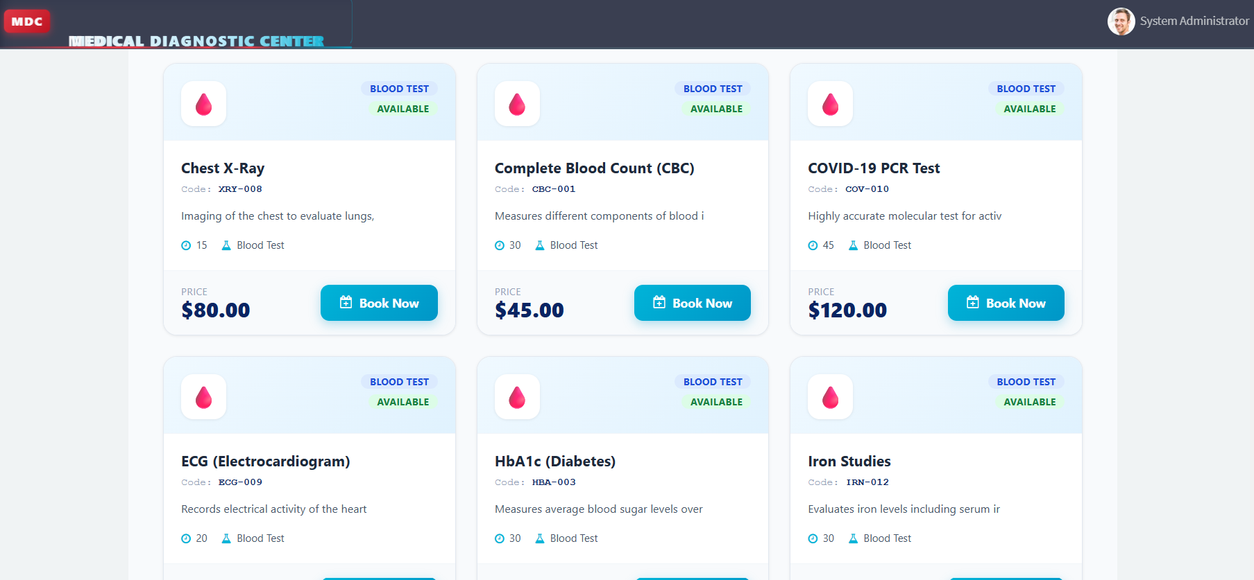
10 | Overall Result | Application workflow tested successfully. The system supports the intended diagnostic center workflow from test selection and appointment booking to report access. | 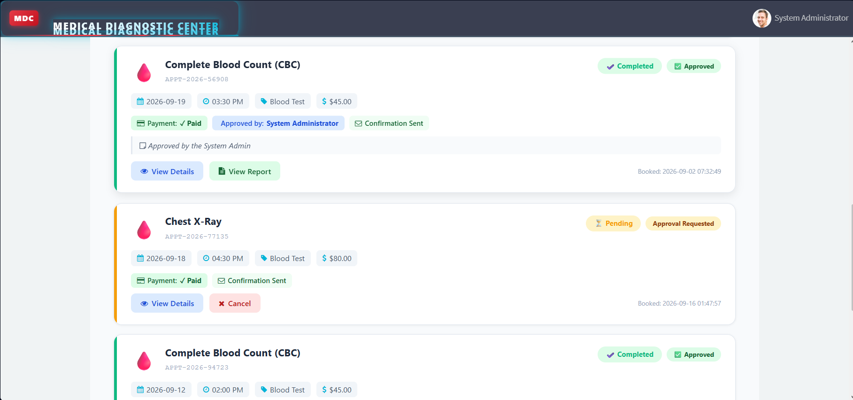

Model Accuracy / Training Results
Parameter | Result
Training Accuracy | Not Applicable – No Machine Learning Model Used
Validation Accuracy | Not Applicable – No Machine Learning Model Used
Fine-Tuning Result | Not Applicable – No Machine Learning Model Used
Application Functional Testing | Successfully Tested
Automation Testing | Successfully Tested
Service Portal Testing | Successfully Tested

Testing Summary
The Medical Diagnostic Center application was evaluated through functional and workflow testing rather than machine-learning model accuracy. The major modules—including diagnostic test browsing, appointment booking, payment status, appointment management, automated report generation and laboratory report viewing—were tested against the expected application workflow.

